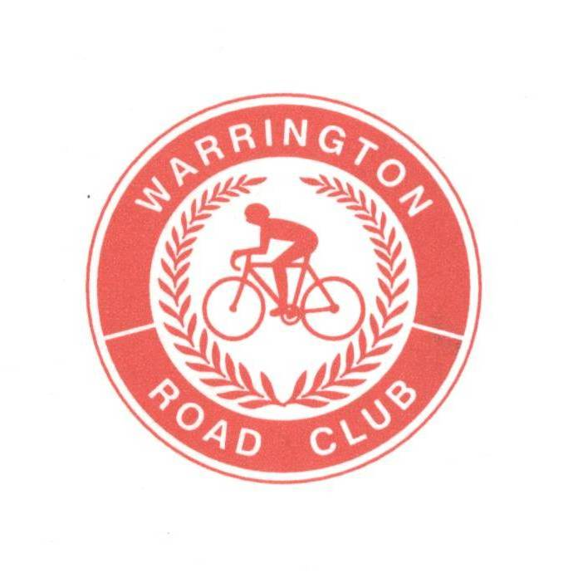
WARRINGTON ROAD CLUB

RESULTS SHEET
Event Secretary:
Darrell Webster
43 Farmleigh Gardens

25 MILE 2 UP TEAM TIME TRIAL

FOUNDED 1923
Great Sankey
Warrington
WA5 3FA
Tel: 01925 816874



PROMOTED FOR AND ON BEHALF OF CYCLING TIME TRIALS UNDER THEIR RULES AND REGULATIONS

SATURDAY 1st OCT 2022 @ 2.00 pm - Course J2/9
TIMEKEEPERS Jim Williams and Bob Norton

Prize Winners (One team one prize)

Fastest Team

Position | Name | Club | Time | Prize
First | Jozsef Evans  Matthew Wales | Fibrax Wrexham | 52.27 | £50
Second | Mark Lovatt  Chris Quinn | Congleton CC – My Windsock  Bioracer Uk RT | 54.31 | £30
Third | Stephen Feeney  Peter Linfield | Tatic Sport UK RT | 54.46 | £20

Fastest Club Team

Position | Name | Club | Time | Prize
First | Joseph Cadwallader  Neil Swithenbank | 360 Cycling | 56.15 | £50

Fastest LadiesTeam

Position | Name | Club | Time | Prize
First | Clare Harrison  Alice Taylor | Congleton CC – My Windsock | 1.01.36 | £50

Thank you all for supporting this event. We had a good mixture of teams and great turnout and the weather was good for a change.
Congratulations go to Jozsef Evans & Mathew Wales with a very convincing winning time of 52.27
Big thanks to Barry George who helped massively on the day
I would like to say a thank you to all the Marshals, Timekeepers and Headquarters officials for giving up their Saturday afternoon especially Julie, Thomas & Kath who kept the HQ running and served refreshments whilst I was out on the course.
The event will back next year on Saturday 30th September 2023. Have a great winter and I hope to see you all again next year.

Kind regards

Darrell Webster
Warrington RC

